A/Prof Nicholas Ngui MBBS (Hons, UNSW) FRACS

THYROIDECTOMY

What is the thyroid gland?
The thyroid gland is a butterfly shaped gland located at the lower front part of the neck. It is usually not visible but can be visible when enlarged. It’s purpose is to produce thyroid hormone which regulates your body’s metabolic rate.

What is a thyroidectomy?
This is the surgical removal of the thyroid gland. A total thyroidectomy is removal of the entire gland, while a hemi-thyroidectomy is removal of one half of the thyroid gland. This is performed through a small scar (about 5cm) at the base of the neck.

Why is a thyroidectomy performed?
Reasons include:
- Thyroid cancer
- Enlarged thyroid gland (goitre) causing problems with swallowing or breathing
- Overactive thyroid (hyperthyroidism). This is where the thyroid overproduces thyroid hormone. Often anti-thyroid medication are used initially. Other options include using radioactive iodine therapy.
- Atypical or suspicious thyroid nodules. Sometimes a fine needle biopsy may give not give a definite result but looks suspicious or atypical. Usually part of the thyroid needs to be removed (hemithyroidectomy) to give the definitive diagnosis.

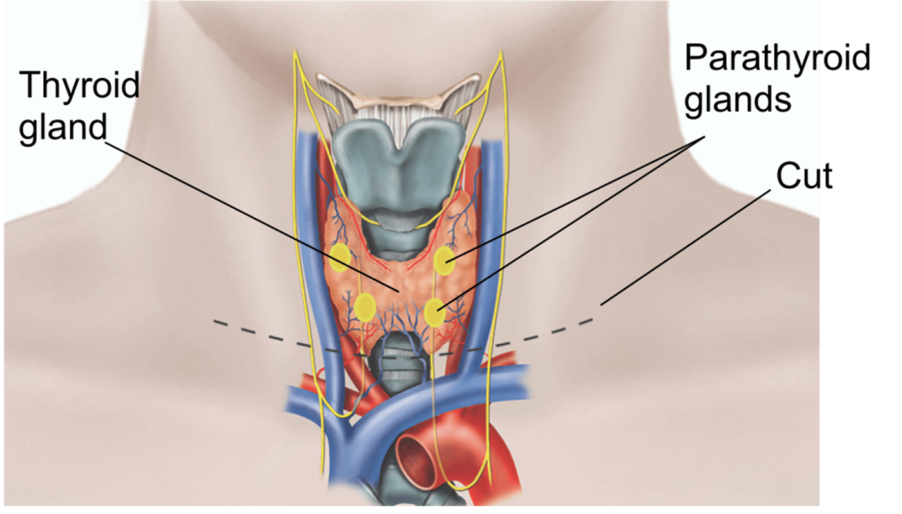
Recurrent
laryngeal
nerves

What are the risks of thyroidectomy?
All operations come with risks, even in the best of hands. The risks with thyroid surgery are fortunately rare. The important risks specific to a thyroidectomy include:
- Vocal cord complications. Temporary hoarseness of the voice can occur in about 10% of cases and most settle within 3 months. It is due to vocal cord bruising or temporary weakness (neuropraxia) of the recurrent laryngeal nerve. The recurrent laryngeal nerves are very important nerves that supply the vocal cords and make them move to allow you to talk. There are two recurrent laryngeal nerve, one supplying each vocal cord. Permanent injury to a recurrent laryngeal nerve can occur in about 0.5% of cases. This leads to paralysis of one of the vocal cords. This results in severe huskiness of the voice and difficulty swallowing. Often the opposite vocal cord compensates and the voice and swallow may return to near normal after several months. Vocal cord surgery and speech therapy may help with this. If both nerves are injured and do not recover which is extremely rare, this may require a tracheostomy breathing tube. The risk of a recurrent laryngeal nerve injury is higher for large goiters, very overactive thyroids where the gland is very adherent to surrounding structures including the recurrent laryngeal nerve, and in thyroid cancers where lymph node dissections may be required.
- Bleeding- this is very rare and occurs in less than 0.5%. This may manifest as acute swelling of the neck usually within 12 hours after surgery. This requires immediate return to theatre to remove the blood under the scar.
- Low calcium levels due to low parathyroid hormone. This is rare after a hemithyroidectomy but can occur in about 25% after a total thyroidectomy. This is almost always transient, due to the 4 parathyroid glands behind the thyroid gland not functioning normally after surgery. This manifests as tingling and numbness around the lips and fingers, and muscle cramps. After a total thyroidectomy you will routinely commence on calcium tablets for about 1 week to buffer this temporary calcium drop. Permanently low calcium levels due to all 4 parathyroid glands not functioning is extremely rare (less than 0.5%), in these cases lifelong calcium and vitamin D tablets are required.

What does surgery involve?
Please bring in all your films on the day of the surgery. Prior to surgery a vocal cord check will be performed by an ear nose and throat surgeon, or by A/Prof Ngui just prior to the surgery with a nasoendoscope. The surgery is performed under a full general anaesthetic. The specialist anaesthetist inserts a tube past the vocal cords. This is connected to a nerve detector (NIM monitor) that A/Prof Ngui uses during the surgery. This helps to detect and locate the important recurrent laryngeal nerves and to check that they are functioning at the end of the surgery. A scar is made at the base of the neck and the thyroid gland is carefully removed with loupe magnification whilst the recurrent laryngeal nerve(s) are carefully preserved with the parathyroid glands. The thyroid specimen is then sent to the pathology lab for full testing. The central neck lymph nodes may also be dissected out if the surgery is for cancer. Local anaesthetic is given during the surgery so that when you wake up, there should not be severe pain. You may have a sore throat from the anaesthetic tube.

What to expect after surgery
- Usually you stay in hospital 1-2 days after surgery.
- You will be able to eat soft foods. Simple pain killers such as paracetamol + Celecoxib will be prescribed.
- If you have had a total thyroidectomy, you will be prescribed thyroid hormone tablets (dose 100-200mcg daily) and calcium tablets (usually 2 tablets every 8-12 hours). You will have a blood test after surgery if you have had a total thyroidectomy to check the calcium levels. If this is low, you may also be prescribed calcitriol (Vitamin D) tablets for up to a week.
- Leave the scar alone. The stitch is under the skin and does not need to be removed as it dissolves. The scar will be sealed off with a skin dressing which is waterproof and you can have light showers.
- Expect some minor swelling under the scar, however if you get sudden swelling or have difficulty breathing you must present to the hospital immediately.
- You will see A/Prof Ngui as arranged back at his clinic (usually 1-2 weeks after surgery). The pathology report of the thyroid gland will be back and will be discussed.
- Most people take about 2 weeks leave from work. You cannot drive for about 1 week. You must be able to turn your neck to see properly before you can drive.

