PARATHYROIDECTOMY

What are parathyroid glands?
The parathyroid glands are tiny glands (about 3mm each) usually located behind the thyroid gland. There are usually 4 parathyroid glands. In some cases they can be located in unusual areas including the chest. The thyroid gland is a butterfly shaped gland located at the lower front part of the neck. The main purpose of the parathyroid glands is to produce parathyroid hormone (PTH). This helps to control calcium metabolism and calcium levels in the body. In rare situations, one or more of these parathyroid glands become overactive (hyperparathyroidism) resulting in excessive production of PTH. This increases the calcium levels in the blood. In most cases (85%) it is due to a single benign tumour known as a parathyroid adenoma. In very rare cases (less than 0.5%) this is a cancerous tumour. 15% can be due to more than one overactive parathyroid glands.

What are the consequences of hyperparathyroidism?
High levels of PTH results in increased calcium levels in the blood. Many patients are asymptomatic, but some can have vague symptoms such as tiredness, fatigue, depression, weakness, bone pain, nausea and constipation. If not corrected this can also lead to potentially serious health problems such as kidney stones, osteoporosis, pancreatitis and cardiovascular disease.

What is a parathyroidectomy?
This is surgery involving searching for, locating and removing the problem parathyroid gland(s). A/Prof Ngui uses an ultrasound during the operation to locate the affected parathyroid gland and a small incision about 3cm is made in the neck. The parathyroid gland/adenoma is then carefully removed. This is also known as a “minimally invasive parathyroidectomy”. Sometimes a larger incision is required (see below) and the scar is about 5cm at the front of the lower neck. Prior to surgery you would have had several radiology imaging scans (Ultrasound + CT scan and/or Sestamibi nuclear scan) to locate the problem parathyroid gland/adenoma that needs to be removed. Most cases (95%) have a successful outcome with the hyperparathyroidism condition being permanently cured.

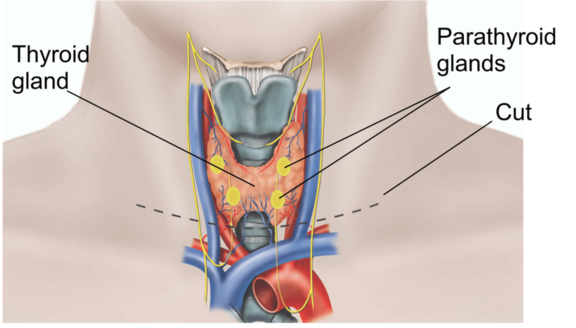
Recurrent
laryngeal
nerves

What are the risks of parathyroidectomy?
All operations come with risks, even in the best of hands. The risks with parathyroid surgery are fortunately rare. The important risks specific to a parathyroidectomy include:
- Vocal cord complications. Temporary hoarseness of the voice can occur in about 10% of cases and most settle within 3 months. It is due to vocal cord bruising or temporary weakness (neuropraxia) of the recurrent laryngeal nerve. The recurrent laryngeal nerves are very important nerves that supply the vocal cords and make them move to allow you to talk. There are two recurrent laryngeal nerve, one supplying each vocal cord. Permanent injury to a recurrent laryngeal nerve can occur in about 0.5% of cases. This leads to paralysis of one of the vocal cords. This results in severe huskiness of the voice and difficulty swallowing. Often the opposite vocal cord compensates and the voice and swallow may return to near normal. Vocal cord surgery and speech therapy may help.
- Bleeding- this is very rare and occurs in less than 0.5%. This may manifest as acute swelling of the neck usually within 12 hours after surgery. This requires immediate return to theatre to remove the blood under the scar.
- Thyroidectomy- In about 5% of cases if the parathyroid gland cannot be found, a partial thyroidectomy where one lobe of the thyroid is removed may be required as the parathyroid gland may sometimes be located inside the thyroid gland. If part of the thyroid is removed, in some patients they may require lifelong thyroxine tablets to replace the thyroid hormones if the remaining thyroid gland cannot produce enough thyroid hormone.
- Persistent hyperparathyroidism- in about 5% of cases the surgery is not successful and the parathyroid adenoma cannot be found. This is more likely if the radiology scans cannot confidently locate the problem parathyroid gland(s) or if it is located in unusual areas. This may then involve re-imaging followed by re-attempting the operation in the future. In some cases there may be another parathyroid gland that is also overactive and will also need to be removed to correct the hyperparathrydism either during the same operation or at a subsequent operation (stage two).

What does surgery involve?
On the day of the surgery you MUST bring all the hard copies of the radiology films (ultrasound/CT scans/sestamibi scans) you have had. If you have not got these, you must go back to your radiology centre to have the films re-printed. Prior to surgery a vocal cord check will be performed by an ear nose and throat surgeon, or by A/Prof Ngui with a nasoendoscope just prior to the surgery. The surgery is performed under a full general anaesthetic. The specialist anaesthetist inserts a tube past the vocal cords. This is connected to a nerve detector (NIM monitor) that A/Prof Ngui uses during the surgery. This helps to detect and locate the important recurrent laryngeal nerves and to check that they are functioning at the end of the surgery. A/Prof Ngui then locates the parathyroid gland with ultrasound. A minimally invasive scar is made in the lower neck and the thyroid gland is carefully mobolised with loupe magnification whilst the recurrent laryngeal nerve(s) are carefully preserved. The overactive parathyroid gland is then removed. The specimen is then sent to the pathology lab for full testing (and in some hospitals such as Norwest and San, frozen section is performed giving immediate confirmation). If the parathyroid gland is not located, then the scar is lengthened from a minimally invasive scar to a longer scar about 5cm to allow a thorough parathyroid exploration. In about 5% of cases if a parathyroid gland is not located after prolonged searching, a hemithyroidectomy may need to be performed. Local anaesthetic is given during the surgery so that when you wake up, there should not be severe pain.

What to expect after surgery
- You will stay overnight after surgery
- You will have a blood test immediately after the surgery and the next morning to check the calcium and PTH levels. These both drop if the operation has been successful.
- You will be able to eat soft foods. Simple pain killers such as paracetamol + Celecoxib will be prescribed.
- You may have a sore throat from the anaesthetic tube and your voice may be a little croaky and weak for about a week after surgery
- Leave the scar alone. The stitch is under the skin and does not need to be removed as it dissolves. The scar will be sealed off with a skin dressing which is waterproof and you can have light showers.
- Expect some minor swelling under the scar, however if you get sudden swelling or have difficulty breathing you must present to the hospital immediately.
- You will see A/Prof Ngui as arranged back at his clinic (usually 1-2 weeks after surgery). The pathology report of the parathyroid gland will be back and will be discussed.
- Most people take about 1-2 weeks leave from work. You cannot drive for about 5 days. You must be able to turn your neck to see properly before you can drive.

